Blizzard in a Bag

January 29 snow day, due on March 7
Recycled Color Wheel
Haplea 8th Grade
Materials needed: scissors, paper, magazines, glue, altered book and any recyclable object.

Color wheel: An abstract illustrative organization of color hues around a circle that shows relationships between primary, secondary, intermediate and complementary colors.

Collage: A technique of art production, used in the visual arts, where the artwork is made from an assemblage of different forms, thus creating a new whole.

Day 1
41 minutes or more.

- Start with your open book, two pages that lack bright colors, I used a black and white magazine cover so my colors would show nicely. This will be the base to your color wheel collage.

- Starting with the primary colors, yellow, blue, red, start cutting shapes and objects from magazines or recyclable objects. Glue these clippings to your base in a triangular formation.

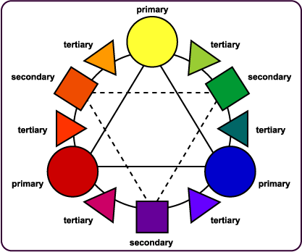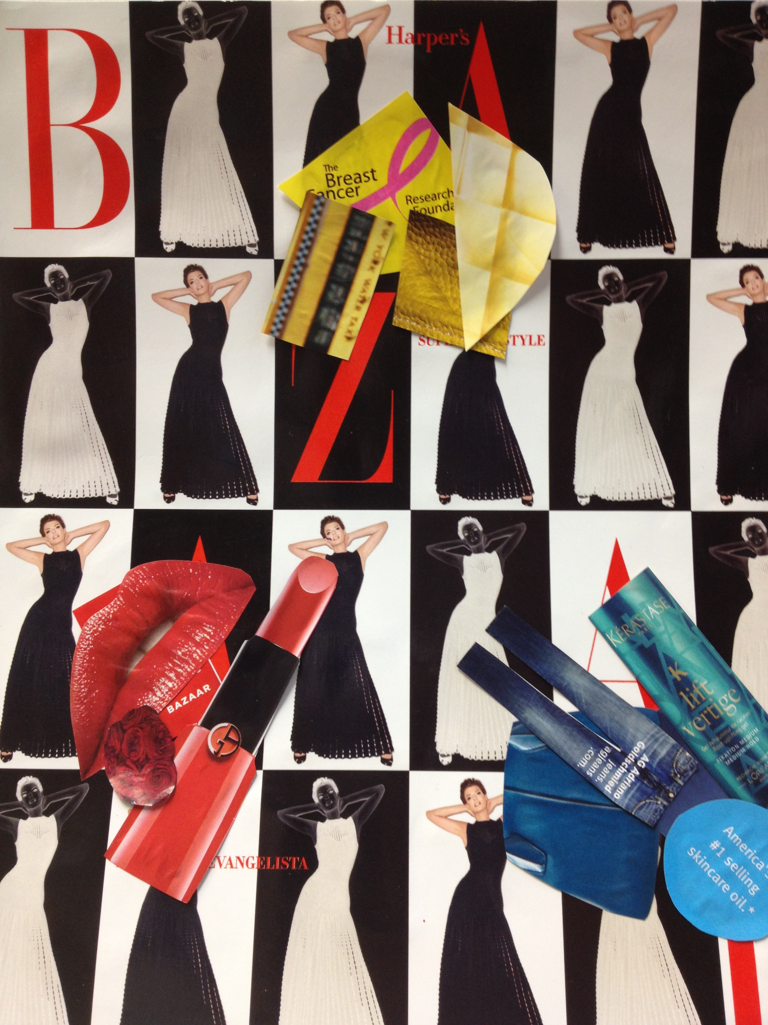

The first day is primary colors only, clip five or more examples of each color and glue them down in the correct placement. Above is an example of the color wheel and my work in progress.

